

**TECHNO INTERNATIONAL NEW TOWN**

**(Formerly known as Techno India College of Technology)**

**Block-DG, Action Area 1, New Town, Kolkata -700156, West Bengal, India**

**Department of Computer Science & Engineering**

**Eight Semester Project Report (CS892)**

**Smart Traffic Management System Using IoT**

***Prepared by***

**Anuj Kumar Gupta (Roll No: -18700117077)**

**Sambhavi (Roll No: -18700117040)**

**Raja Jha (Roll No: -18700117048)**

**Aayush Mantri (Roll No: - 18700117088)**

**Kumar Aman (Roll No: - 18700117061)**

***Under the Guidance of***

**Prof. Debraj Chatterjee**

***Batch: - 2017-2021******Semester :8 th (2021-ODD) Year: April 2021 – July 2021***

***Stream: - Computer Science & Engineering Year of Study: 4th***

***Affiliated to***



**MAULANA ABUL KALAM AZAD UNIVERSITY OF TECHNOLOGY, WESTBENGAL**

**(FORMERLY KNOWN AS WEST BENGAL UNIVERSITY OF TECHNOLOGY)**

**ACKNOWLEDGEMENT**

We would like to express our sincere gratitude to Prof. Debraj Chatterjee of the Department of Computer Science & Engineering, whose role as project guide was invaluable for the project. We are extremely thankful for the keen interest he took in advising us, for the books and reference materials provided for the moral support extended to us.

Last but not the least we convey our gratitude to all the teachers for providing us the technical skill that will always remain as our asset and to all non-teaching staff for the cordial support they offered.

Place: Techno International New Town

Date: 08/07/2021

Anuj Kumar Gupta

(Roll No: 18700117077)

Sambhavi

(Roll No: -18700117040)

Raja Jha (Roll No: -18700117048)

Aayush Mantri

(Roll No: -18700117088)

Kumar Aman

(Roll No: - 18700117061)

Department of Computer Science & Engineering,

Techno International New Town

Kolkata – 700 156

West Bengal, India.

**Approval**

This is to certify that the project report entitled “**Smart Traffic Management System Using IoT**” prepared under my supervision by Anuj Kumar Gupta (Roll no.-18700117077), Sambhavi (Roll no.-18700117040), Raja Jha(Roll no.-18700117048), Aayush Mantri(Roll no.-18700117088), Kumar Aman (Roll no.-18700117061), be accepted in partial fulfillment for the degree of Bachelor of Technology in Computer Science & Engineering which is affiliated to Maulana Abul Kalam Azad University of Technology, West Bengal (Formerly known as West Bengal University of Technology).

It is to be understood that by this approval, the undersigned does not necessarily endorse or approve any statement made, opinion expressed or conclusion drawn thereof, but approves the report only for the purpose for which it has been submitted.

…………………………………………

Prof. Debraj Chatterjee

………………………………………….

Prof. Bikash Sadhukhan,

HOD, Computer Science & Engineering,

Techno International New Town

**Abstract**

Traffic congestion is a severe problem in most cities across the world wide. Increasing number of vehicles, insufficient infrastructure and the irrational distribution of the signaling system are main reasons for the uncontrolled congestions. This not only leads to lot of wastage of the work hours of the individuals but also creates a lot of pollution effecting the environment. So, therefore it is time to shift from manual mode or fixed timer mode to an automated system with decision making capabilities because predefined set time for the signal at all circumstances (low and high traffic density) has not solved this problem. Under current circumstances, traffic lights are set on in the different directions with fixed time delay, following a particular cycle while switching from one signal to other creating an unwanted and wasteful congestion on one lane while the other lanes remain vacant.

So, we propose here a mechanism or a model using IOT in which the time period of green light, yellow light and red light is assigned on the basis of density of the traffic present at that time. This is achieved by using IR (Infrared sensors). The sensors which are present at the side of each lane will count the number of the vehicles passing by and sends the information (Vehicle count) to the microcontroller where it will decide which route will be open or when to change over the signal lights. In subsequent sections, we have elaborated the procedure of this framework.

**CONTENTS**

**Page No.**

1. **INTRODUCTION ………………………………..………………….…………7-9**
2. **PROBLEM DEFINITION………………………………………………..…… 10**
3. **ARCHITECTURE …………………………………………………………….. 11**
4. **DATA FLOW DIAGRAM (DFD)……………………………………………. 12**
   1. **Context Level Diagram**
5. **ENTITY RELATIONSHIP DIAGRAM (ERD)……………………………... 13**
6. **USE CASE DIAGRAM………………………………………………………... 13**
7. **ACTIVITY DIAGRAM………………………………………………………… 14**
8. **SEQUENCE DIAGRAM……………………………………………………… 15**
9. **FUTURE SCOPE OF PROJECT……………………………………………... 16**
10. **CONCLUSION………………………………………………………………… 16**
11. **BIBLIOGRAPHY……………………………………………………………… 17**

**LIST OF FIGURES**

**Figure Caption…………………………………………………………… Page No.**

**Fig 1.1 Basic Function of IoT………………………………………... 9**

**Fig 3.1 Flowchart of Smart Traffic Management System…………. 11**

**Fig 3.2 Project Model………………………………………………… 11**

**Fig 4.1 Context Level Diagram……………………………………… 12**

**Fig 5.1 E-R Diagram…………………………………………………. 13**

**Fig 6.1 Use Case Diagram…………………………………………… 13**

**Fig 7.1 Activity Diagram……………………………………………... 14**

**Fig 8.1 Sequence Diagram…………………………………………… 15**

1. **Introduction**

Traffic congestion has become a serious issue in today’s high-speed life which creates a heavy impact on our day-to-day activity. This leads to the wastage of a lot of work hours of the individuals in the signal which directly impact their efficiency and productivity. Increasing number of vehicles, insufficient infrastructure and the irrational distribution of the signaling system are main reasons for the uncontrolled congestions. It indirectly also adds to the increase in pollution level as engines remain on in most cases, a huge volume of diesel is consumed without any fruitful outcome. So, in order to solve these problems or to minimize them to satisfactory level, newer schemes need to be implemented by using sensor-based automatic traffic signaling system.

**About IoT:**

The Internet of Things (IoT), also referred to as the Internet of Everything (IoE), consists of all the web-enabled devices that collect, send and act on data they receive from their surrounding environments using sensors, processors and other communication hardware devices. These devices can talk to the other related devices and can act on the information they get from each another. Humans can interact with these devices to set them up and give them instructions. These devices do most of the work on their own without the interference of human. These devices produce huge amounts of Internet traffic, which includes loads of data that is used to make the devices resourceful, but can also be used for other motives. These data and the accessible nature of the devices, raises both privacy and security concerns for the user. But this technology helps in providing us with a real-time information that we have never experienced before. We can use this technology to monitor our homes, offices, close-ones and families remotely to keep them safe and secure. It provides a way for businesses to improve their processes in order to increase their productivity and reduce waste generated and unaccepted downtime or any kind of loss. Sensors in city infrastructure can help to minimize road congestion and inform us when infrastructure is in any kind of danger. Devices based on IoT can monitor for the changing weather and environment conditions and can warn us beforehand of any approaching disasters.

**Advantages of IoT:**

**Connectivity:**

IoT has brought an end to the era of manually operating different devices for every task and have provided us with the ability to operate multiple things from one device, for example, smart phones. From controlling your thermostat to turning up the volume on the TV to diming the lights and more, soon every device will be connected for streamlined control. IoT encourages the communication between devices and they can interact and share data with each other. Because of this, the physical devices are able to stay connected and hence it leads to total transparency with lesser inefficiencies and greater equality.

**Automation and control:**

Since physical objects are getting connected and controlled digitally and centrally with wireless infrastructure, there is a large amount of automation and control in the workings. Without human intervention, the machines are able to communicate with each other leading to faster and efficient output.

**Access Information:**

You can easily access data and information while sitting far away from the location, in real time. This is possible because of the network of devices; a person can access any information sitting from any other part of the globe. This makes it too easier for people to go for their work, even if they are physically absent.

**Improve Monitoring:**

The second most obvious advantage of IoT is monitoring. Knowing the exact quantity of supplies or the air quality in your home, can further provide more information that could not have previously been collected easily. For example, knowing that you are low on milk or printer ink could save you from another trip to the store in the near future. Furthermore, monitoring the expiration of products can and will improve safety.

**Saves Time:**

As IoT decreases the human effort hence it definitely saves out time. Time is the primary factor which can be saved through IoT platforms. The amount of time saved because of IoT could be quite large.

**Wellness:**

Whether you have invested in wearable technology or not, there are many ways to monitor your health goals using the IoT. A withing scale can record your weight and body consumption, provide suggestions, and reward progress towards weight loss goal.

**Disadvantages of IoT:**

**Security and Privacy:**

Security and privacy remain a major issue that scare off the users from IoT technology for medical purposes, as healthcare monitoring solutions have the potential to be breached or hacked. The leak of sensitive information about the patient’s health and location and meddling with sensor data can have severe consequences, which would counter the benefits of IoT.

**Risk of failure:**

Failure or bugs in the hardware or even power failure can impact the performance of sensors and connected equipment placing healthcare operations at risk. In addition, skipping a schedule software update may be even more hazardous than skipping a doctor checkup.

**Integration:**

There’s no consensus regarding IoT protocols and standards, so devices produced by different manufacturers may not work well together. The lack of uniformity prevents full scale integration of IoT, therefore limiting its potential effectiveness.

**Lesser Employment of Manpower:**

The unskilled workers and helpers may end up losing their jobs in the effect of automation of daily activities. This can lead to unemployment issues in the society. This is a problem with the advent of any technology and can be overcome with education. With daily activities getting automated, naturally, there will be fewer requirements of human resources, primarily, workers and less educated staff. This may create Unemployment issue in the society.

**Cost:**

While IoT promises to reduce the cost of healthcare in the long term, the cost of its implementation in hospitals and staff training is quite high.

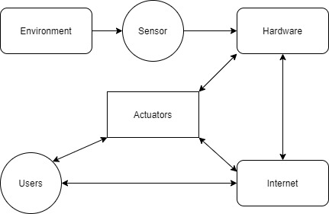

Fig 1.1: Basic Function of IOT

**IoT in Traffic Management:**

Traffic management is one of the biggest infrastructure hurdles faced by developing countries today. Developed countries and smart cities are already using IoT and to their advantage to minimize issues related to traffic. The culture of the car has been cultivated speedily among people in all types of nations. In most cities, it is common for people to prefer riding their own vehicles no matter how good or bad the public transportation is or considering how much time and money is it going to take for them to reach their destination.

1. **Problem Definition**

**Present Traffic Signaling System:**

Under present scenario, traffic control is achieved by the use of a system of hand signs by traffic police personnel, traffic signals and marking. Under current circumstances, traffic lights are set on in the different directions with fixed time delay, following a particular cycle while switching from one signal to other creating unwanted and wasteful congestion on one lane while the other lanes remain vacant.

**Proposed Model:**

The system we propose identifies the density of traffic on individual lanes and thereby regulate the signals timing. IR sensors count the number of vehicles and provide an idea about the traffic density on a particular lane and feed this response to a controller unit which will make the necessary decisions as and when required.

1. **Architecture**

**Flow Chart:**

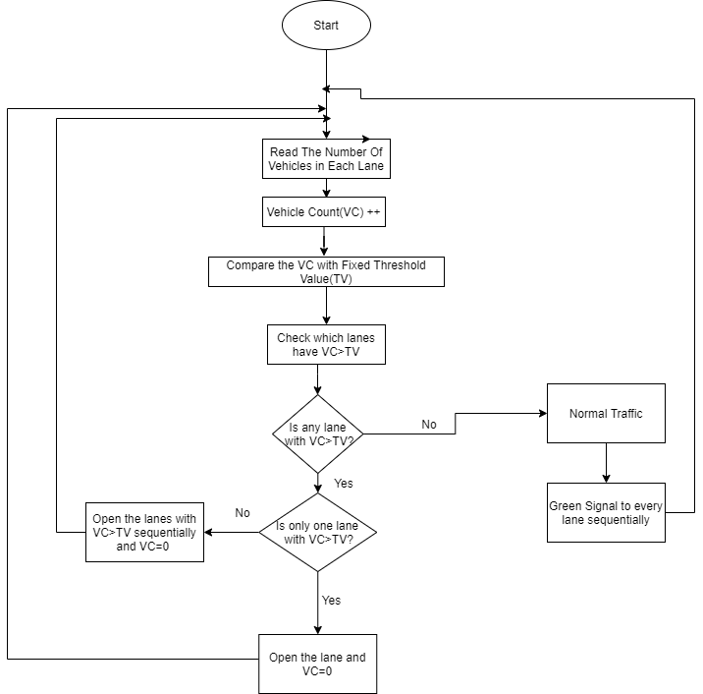

Fig 3.1: Flowchart of Smart Traffic Management System

**Project Model:**

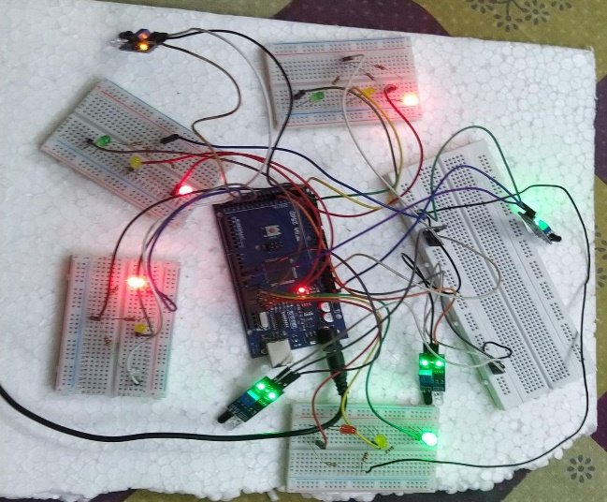

Fig 3.2: Project Model

**4. Data Flow Diagrams (DFD):**

**4.1 Context Level Diagram:**

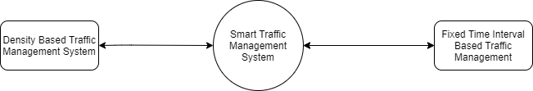

Fig 4.1 Context Level Diagram

**5. Entity Relationship Diagrams**

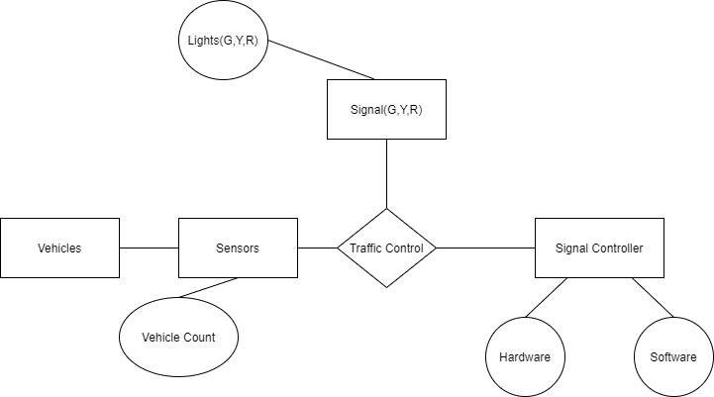

Fig 5.1: E-R Diagram

**6. Use Case Diagram**

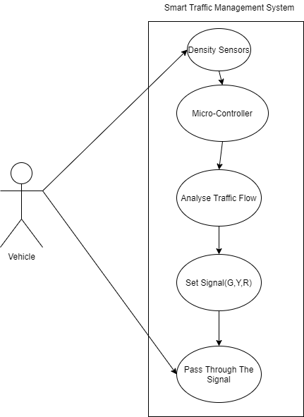

Fig 6.1: Use Case Diagram

**7. Activity Diagram**

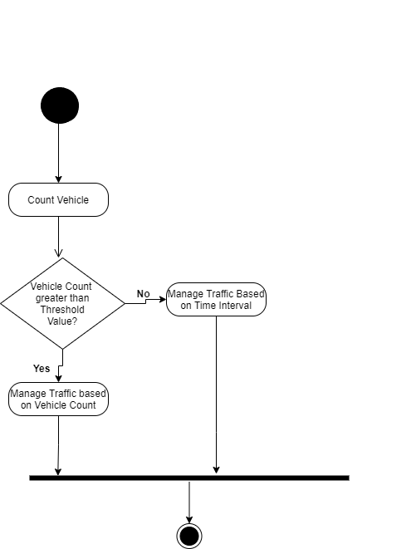

Fig 7.1: Activity Diagram

**8. Sequence Diagram**

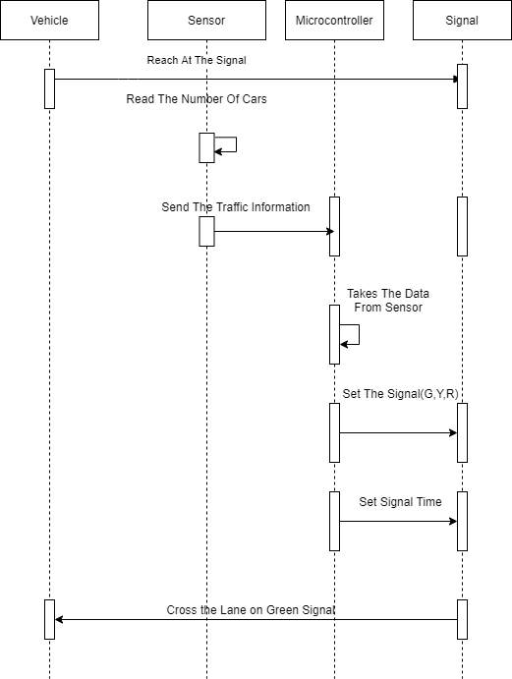

Fig 8.1: Sequence Diagram

**9. Future Scope of the Project:**

This project still has space for the improvements. Our proposed model has the limited number of decision-making capabilities as it identifies the density on each lane and based on density it will take care of signal lights. But what happens if an emergency vehicle comes into that lane having lesser sensity, then it will get stuck on the lane. One of the limitations of our proposed model is low range IR sensors which may not be an answer for the long-range signaling system. Instead of IR sensors we can use some long range and more efficient sensors. We can also introduce RF Module with RFID system which will be make the model more efficient for detecting emergency vehicles. Next is influence of stray signals that may alter the reading of the sensors receptors and lead to conveying false information to the microcontroller. In the future we can use **“Image Processing based Intelligent Traffic control using Raspberry pi”** technique. In this system, vehicles are detected by the system through images instead of using electronic sensors embedded in the pavement.

As a part of future advancements, the traffic check post may be connected through wireless transmitter by which the crossing ahead may be an anticipation of the traffic that is approaching. This may be achieved by connecting the sensor network with GPS connectivity and short-wave radio transmission signals. This will act as feedforward system making the signaling system even more smooth and congestion free.

**10. Conclusion**

This project “Smart Traffic Management System using IoT” has been developed using multiple hardware components. We have used Arduino Mega 2560 Microcontroller with IR sensors for calculating the Vehicle Count. In this project traffic optimization is achieved using IoT Platform by efficiently allocating varying times to all traffic signal accounting to available vehicle count in each lane.

This project aims to deliver an effective solution for the rapid growth of traffic flow particularly in big cities which is increasing day by day and to reduce the need for manual traffic control system. The traditional methods have certain limitations as they fail to manage heavy traffic properly. This system changes the signal timing intelligently according to traffic density and hence regulates traffic flow.

**11.Bibliography**

**11.1**.Er. Faruk Bin Poyen, Amit Kumar Bhakta, “Density Based Traffic Control”, International Journal of Advanced Engineering Management and Science (IJAEMS), Vol- 2, Aug- 2016,1379-1384

**11.2**.[http://centrallibrary.cit.ac.in/dir/Project%20Report/2019/BTech/CSE/Smart%20Traffic%20 Management%20System%20using%20Internet%20of%20Things%20%28IoT%29.pdf](http://centrallibrary.cit.ac.in/dir/Project%20Report/2019/BTech/CSE/Smart%20Traffic%20%20%20%20Management%20System%20using%20Internet%20of%20Things%20%28IoT%29.pdf)

**11.3.**<https://innovationatwork.ieee.org/6-iot-benefits/>

**11.4**.<http://www.ir.juit.ac.in:8080/jspui/bitstream/123456789/15666/1/121057.pdf>

**11.5.**Anam Firdous, Vandana Niranjan, Smart Density Based Traffic Light,2020 8th International Conference on Reliability, Infocom Technologies and Optimization (Trends and FutureDirections)(ICRITO),4-5June2020 (<https://scihub.se/https://ieeexplore.ieee.org/abstract/document/9197940>)

**11.6.**http://ijariie.com/AdminUploadPdf/DENSITY_BASED_TRAFFIC_LIGHT_CONTROL_USING_ARDUINO_ijariie9121.pdf

**11.7.** https://www.rcciit.org/students_projects/projects/ee/2019/GR17.pdf

**---------------------------------------------X--------------------------------------------------------**